ACI EC2 Questions, Sample solutions and Marking scheme
Q1.
In the context of a sliding tile puzzle featuring six tiles (three red and three green) within a linear tray capable of holding seven tiles, denoted as R for red, G for green, and E for the 'empty' tile, an agent aims to discover a sequence of legal moves or swaps from the initial state to reach the goal state. The puzzle allows two types of moves: [3+3+4 =10 Marks]

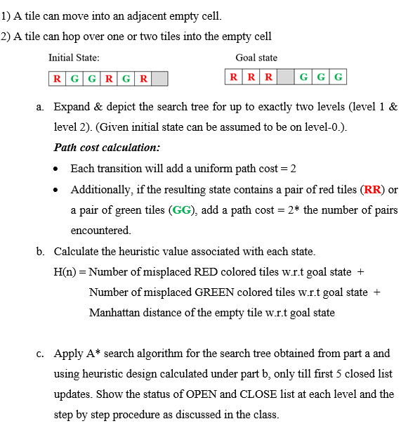

Solution:
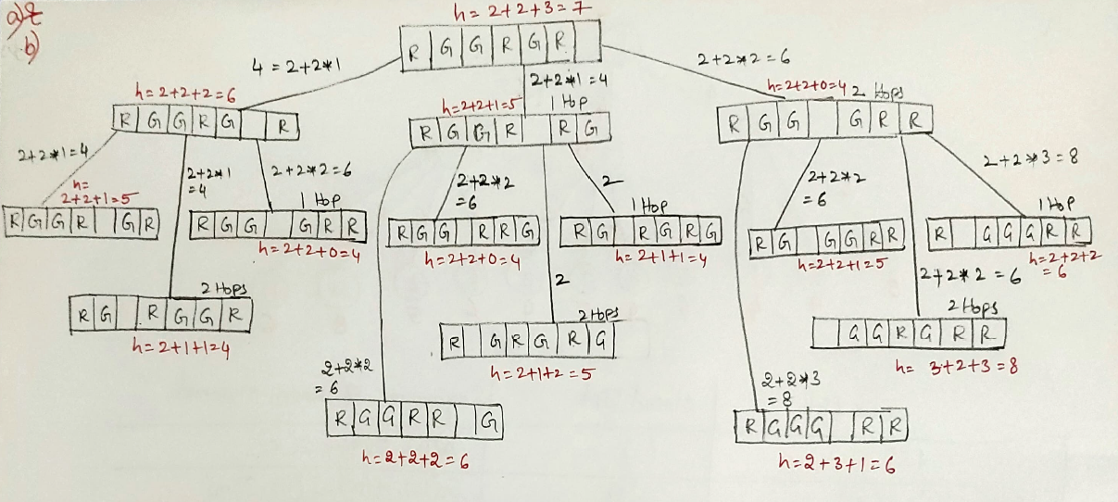

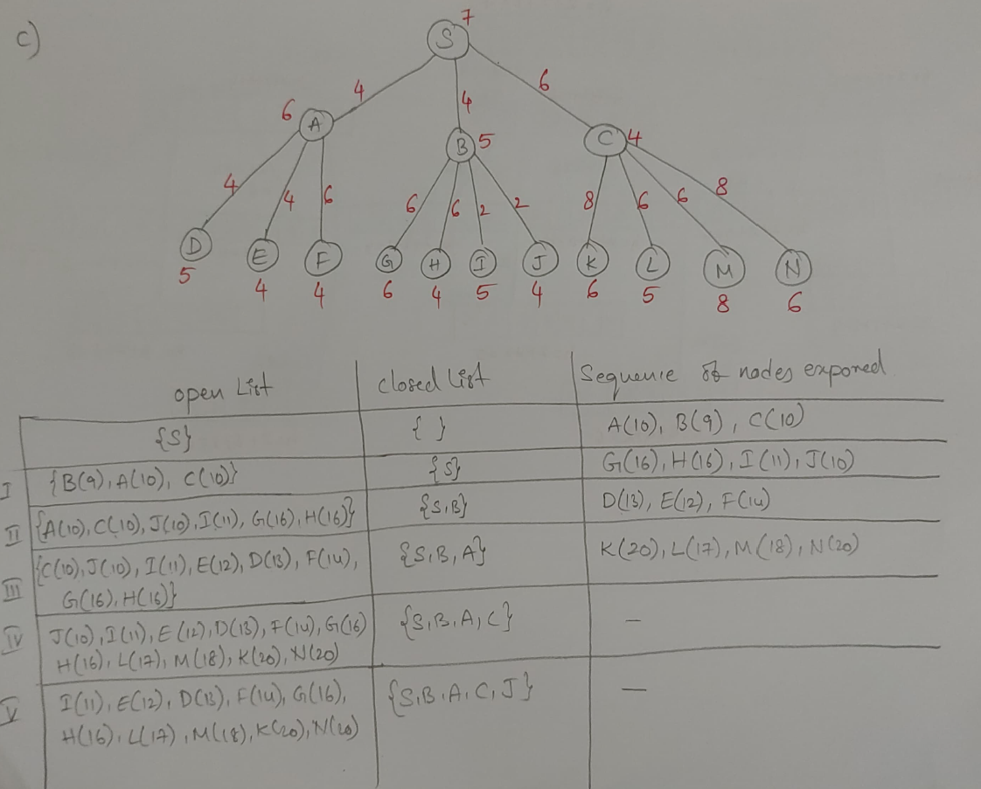

Marking Scheme:
a) Complete proper search Tree - 2M. Calculating path cost - 1M.
b) Heuristic calculation for level-1 and level-1 nodes - 1M, for level-2 nodes - 2M.
c) Correct procedure of A*, Open List and Close list - 3M.

Q2.
Answer to the below question for the following scenarios. Vague theory will not be awarded marks. [2+2+2+2 = 8 Marks]
“Imagine you are tasked with designing an automated traffic monitoring system for a smart city. The system is equipped with 10 cameras strategically placed at key intersections to monitor traffic conditions. It scans for traffic violations and detects license plate numbers to cross-verify with a database of stolen or wanted vehicles.”

- Provide the complete problem formulation.
- Which agent architecture best fits? Why?
- Provide the PEAS description.
- Identify the various dimensions of the task environment with appropriate justification for each in no more than 30 words
Solution:
- Problem formulation:
Initial state : Cameras in positions, Database of traffic violations, licence plate numbers and data about stolen cars reported.
Goal State : Correct identification of traffic violations and detection of licence plates with stolen car numbers
Transition function : At(X, No traffic violation) -> At(Y, Traffic violation detected). At(X, Valid car number) -> At(Y, Stolen car number detected)
Cost : Cost = Maximum detection of cars with traffic violations and stolen cars and minimize false detection
- Learning/Utility/Goal based agents. Justification in not more than 30 words.
- Performance – Correct detection of traffic violation and stolen cars, Environment- Road, traffic, cars, etc., Actuator – Scanning of Cars / Licence plates passing through the cameras, Sensors – Cameras
- Dimensions of task environment – Multi agent, continuous, deterministic, episodic, dynamic. Justification for all the dimensions
Marking scheme:
- Problem formulation:
Initial state, Goal State, Transition function, Cost function (0.5 marks each=2 marks)
- Learning agents/Utility/Goal based agent (1 mark).
Justification in not more than 30 words.(1 mark)
- Performance – Correct detection of traffic violation and stolen cars, Environment- Road, traffic, cars, etc., Actuator – Scanning of Cars / Licence plates passing through the cameras, Sensors – Cameras. (PEAS – 0.5 marks for each = 2 marks)
- Dimensions of task environment – Multi agent, continuous, deterministic, episodic, dynamic. Justification for all the dimensions. (At least 4 dimensions mentioned with justification 2 marks)

Q3.
Consider the search problem shown below, which involves three states connected by three directed edges. The starting node is A, and the target node is G. Four different heuristic functions have been defined. Check the admissible and consistency property for all heuristic design. Determine which design results in the optimal solution with proper approach and justification. [4 Marks]
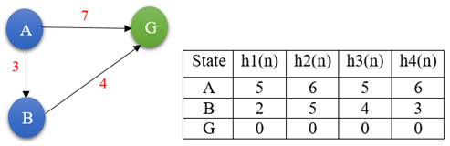

Solution:
To check the admissible and consistency properties of each heuristic function, we need to calculate the heuristic values for each state (h1(n), h2(n), h3(n), h4(n)) and compare them to the actual costs of reaching the goal (G) from the current state (A).
Given heuristic functions and graph is
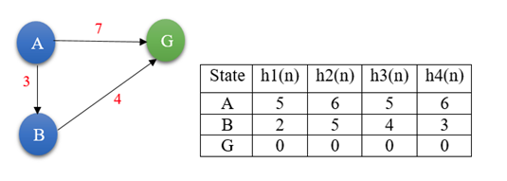
Admissibility: (A heuristic function is admissible if it never overestimates the cost to reach the goal node from any given node. In other words, the estimated cost given by the heuristic function is always less than or equal to the actual cost. ...................OPTIONAL)
i.e. h(n)≤ h*(n). ...................... 0.25 Mark
The true costs are: h*(A) = 7 (A to G), h*(B) = 4 (B to G) and h*(G) = 0 (goal state)
Checking the admissible property:
Heuristic h1(n): h1(A) = 5 ≤ h*(A) = 7, h1(B) = 2 ≤ h*(B) = 4 and h1(G) = 0 ≤ h*(G) = 0
Therefore, h1(n) is admissible.
Heuristic h2(n): h2(A) = 6 ≤ h*(A) = 7, h2(B) = 5 ≤ h*(B) = 4(false) and h2(G) = 0 ≤ h*(G)=0
Therefore, h2(n) is not admissible.
Heuristic h3(n): h3(A) = 5 ≤ h*(A) = 7, h3(B) = 4 ≤ h*(B) = 4 and h3(G) = 0 ≤ h*(G) = 0
Therefore, h3(n) is admissible.
Heuristic h4(n): h4(A) = 6 ≤ h*(A) = 7, h4(B) = 3 ≤ h*(B) = 4 and h4(G) = 0 ≤ h*(G) = 0
Therefore, h4(n) is admissible.
........................... 4 X 0.25 = 1 Mark
Consistency (or Monotonicity): (A heuristic function is consistent if for every node n and every successor n' of n generated by an action, the estimated cost of reaching the goal node from n is no greater than the cost of reaching n' plus the estimated cost of reaching the goal node from n'. ....................OPTIONAL)
i.e., h(n)≤c(n,n′)+h(n′) where c(n,,n′) is the cost of the action from n to n'.
............... 0.25 Mark
Checking the consistency property:
Heuristic h1(n): h1(A) = 5 ≤ c(A, B) + h1(B) = 3 + 2 = 5
h1(B) = 2 ≤ c(B, G) + h1(G) = 4 + 0 = 4
Therefore, h1(n) is consistent.
Heuristic h2(n): h2(A) = 6 ≤ c(A, B) + h2(B) = 3 + 5 = 8
h2(B) = 5 ≤ c(B, G) + h2(G) = 4 + 0 = 4
Therefore, h2(n) is not consistent.
Heuristic h3(n): h3(A) = 5 ≤ c(A, B) + h3(B) = 3 + 4 = 7
h3(B) = 4 ≤ c(B, G) + h3(G) = 4 + 0 = 4
Therefore, h3(n) is consistent.
Heuristic h4(n): h4(A) = 6 ≤ c(A, B) + h4(B) = 3 + 3 = 6
h4(B) = 3 ≤ c(B, G) + h4(G) = 4 + 0 = 4
Therefore, h4(n) is consistent.
................. 4 X 0.5 = 2Marks
Conclusion: The optimal solution is guaranteed when using an admissible heuristic in A* search.
Among the heuristics provided, h1(n), h3(n) and h4(n) are both admissible and consistent.
However, h4(n) results in the optimal solution since it is consistent and admissible, and it doesn't overestimate the true cost to reach the goal from any state.
Therefore, h4(n) is the best heuristic for this search problem.
................ 0.5 Marks
Q4
Imagine a manufacturing facility where four different tasks (Task A, Task B, Task C, Task D) need to be scheduled for production. Each task involves specific resource requirements and completion times. The objective is to efficiently schedule these tasks to minimize resource utilization and completion time, ensuring a streamlined manufacturing process. [ 2+4+2 = 8 Marks]
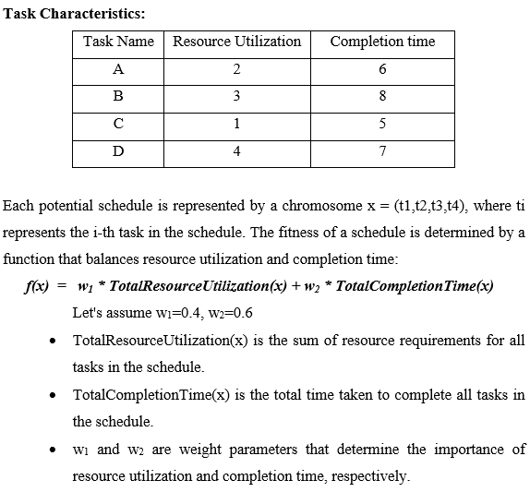
a. Describe the Chromosome representation of a parent state for four randomly selected states with their fitness score.
b. Suggest an appropriate process of selection, crossover and mutation steps for this problem. Show these with only one iteration of numerical example.
c. Informed search is preferred than Local search algorithms". Justify this statement with appropriate plagiarism free scenario or numerical example

Marking Scheme:
- Fitness Score Calculation: 0.5 marks
Chromosomal representation with fitness score: 1.5 marks
- Selection: 1.5 marks
Crossover: 1.5 marks
Mutation: 1 mark
- Any two reasons with plagiarism free scenario or numerical example: 2 marks
Answer Key:
f(x)=w1*Total Resource Utilization(x) + w2*Total Completion time(x)
=0.4*10 + 0.6*26
=4+15.6
=19.6
- Chromosome representation of a parent state for four randomly selected states
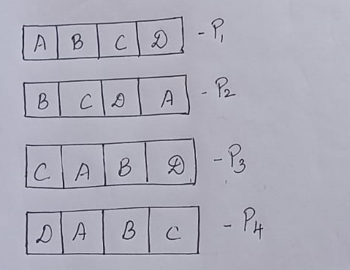
All the states have same fitness score as 19.6
- Selection
Since the fitness value is same for all states, randomization can be used.
Using Roulette wheel, the parent can be used as chance of
P2, P3, P4, P3
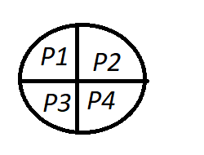

Crossover
Either using single split or multiple split
Single split
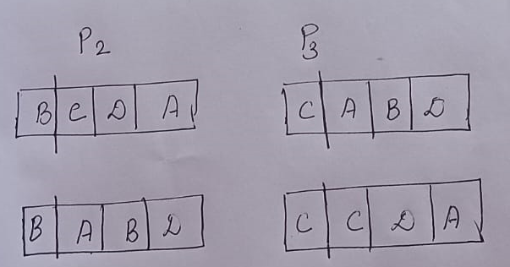

Double Split
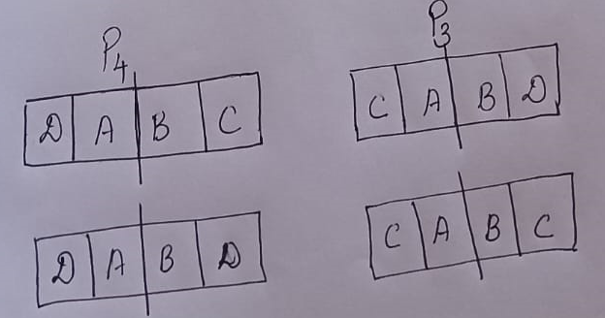

Mutation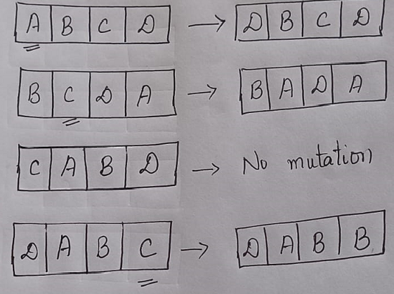
- Any two reasons – 1 Mark
Scenario or numerical example: 1 Mark

